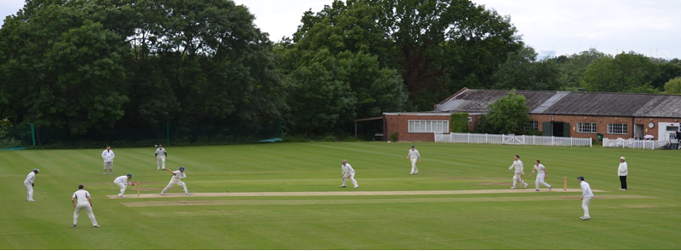
Streatham & Marlborough Cricket Club
CRICKETFORCE 2017 - Update

Hi all,

We are just three days from launching CricketForce 2017 nationally!!!! Steven Finn, Zafar Ansari and Amir Virdi will be at the club along with former England captain Mike Gatting to help with the various projects on the day. Do make every effort to come along on Friday and do your bit for this fantastic cricket club!
Timeline

9:00am registration begins
9:30am work begins
11am-1:30pm England fast bowler Steven Finn (top left) is expected to be at the club.
12:30pm-1:30pm Steven Finn and former England captain Mike Gatting (bottom left) will be doing an autograph and photo session
12 noon-2:30pm England & Surrey all-rounder Zafar Ansari (bottom right) and Surrey and England Young Lion (England U19) Amar Virdi (top right) are expected at the club
Morning and early afternoon - Surrey coaches will be available to run cricket sessions with kids
All day:
- England legend Mike Gatting will also be staying at the club all day to lead one of our CricketForce projects.
- Many volunteers (that’s you and I) will be carrying out lot of projects to help make huge improvements to the club
- We will be doing our own filming (the same members who produced the video on our club website)

Other details

Food & drink: Free breakfast, lunch and beers will be provided by Surrey CCC. There’s likely to be a BBQ in the late afternoon for hungry workers and the bar will be open in the evening
What to wear: Something you don’t mind getting paint on or generally dirty. You will receive a free NatWest CricketForce t-shirt
What to bring: if you have any gardening equipment – please bring it along but keep a close eye on it
How to travel: Please make your way by public transport, cabs or park on nearby residential roads – the car park will be reserved for machinery and dignitaries only.
Safety: Please note there will be various potentially dangerous machinery in use at the club to help achieve our plans. Do take care around them.
Weather: The event will continue regardless of weather conditions so please dress accordingly
Raffle & Auction: We have some fantastic prize donations so there will be an auction and a raffle on the day.

Funding
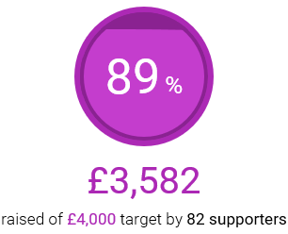
What a phenomenal response to our appeal to raise funds for this event – THANK YOU!!! We are under £500 away from our goal and it would be brilliant to achieve this before the event. Have you donated? It’s not too late to… https://www.justgiving.com/crowdfunding/rajan-patel

Membership
Finally, aside from CricketForce, we have a season to set up for and expenses to pay. The Executive took the decision to push back the ‘early bird’ offer of discounted annual membership fees as a result of this event. However, we would encourage those who are able to pay, to do so now. The early bird offer will now end on 30 April. Details can be found here… http://www.streathammarlboroughcc.co.uk/index.php/membership/

If you need any further information, more can be found on our website. Otherwise, do feel free to contact me.
Cheers,
Dan

