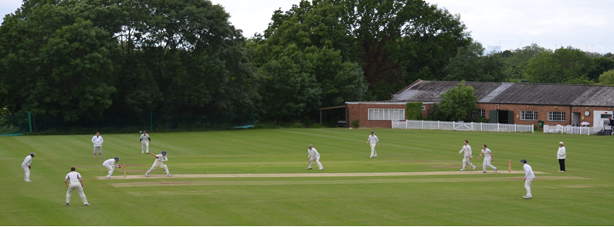
Streatham & Marlborough Cricket Club
Midweek SMS – 7 June 2017

Fixtures | Results | Membership | Club Kit | Fantasy Cricket | Batting Statistics | Bowling Statistics
(Click on these links for further information)

Dear all,

A much improved weekend in the league with three out of four wins for both the seniors and juniors. This weekend we’re back to our full compliment of league teams after a gap weekend for the 5th and 6th XI in Kent.

There were some notable performances over the weekend. In the runs were Jamie Acheson (86), Dan Johnson (66), Neil Shah (58), Ed Lawrence (57), Warren Little (69), Mark Davis (76) and Ben Southworth (88); the bowlers were led by Ed Marquis (4-44), Jordan Lee (5-32) and under 14 junior William Kay (5-20). The selection committee awarded the player of the week to the youngest ever recipient for SMCC – William Kay! I’ll also add that the moment of the season so far was watching the young leg spinner lead the 4th XI from the field having taken the final wicket, through an appreciative guard of honour graciously provided by Walton on Thames CC in front of his proud mother. Great to see!

Now, on to the regular news along with the match reports (which follow at the bottom of the e-mail).

Raj Patel 40th Birthday

The driving force behind the magnificent CricketForce event this year is having a celebration at the club this weekend. He says:
It’s that time in life where I'll be leaving the 30s and turning 40. Everybody playing on Saturday 10th June is welcome to attend (plus other halves) to celebrate with food and dessert provided.
Food will be served between 7:30pm-9pm. Hopefully will see many of you there for a drink!

Neneto Davis – Player/Coach

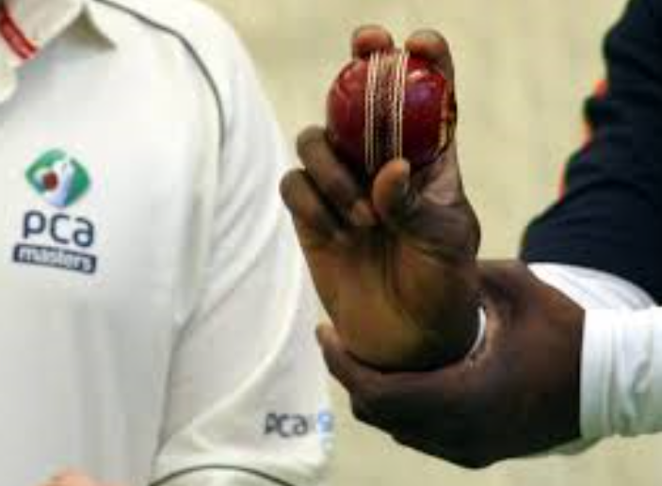 | We’re thrilled to announce that Neneto Davis has agreed to join the club as Player/Coach. Neneto’s played county 2nd XI and is currently a coach at the Ken Barrington Centre at Surrey CCC. He will lead 1st/2nd XI training on a Tuesday evening (6.30pm-8.30pm) and club-wide training on a Thursday evening (6.30pm-8.30pm). In line with the ladies and juniors, we will need to charge a small amount (£2 per session) to contribute to the cost of coaching. Please indicate to Justin Sbresni (07951 601 948) or Kasheef Hassan (07413 040 790) if you are able to attend so we can plan sessions appropriately.
Batting Cages

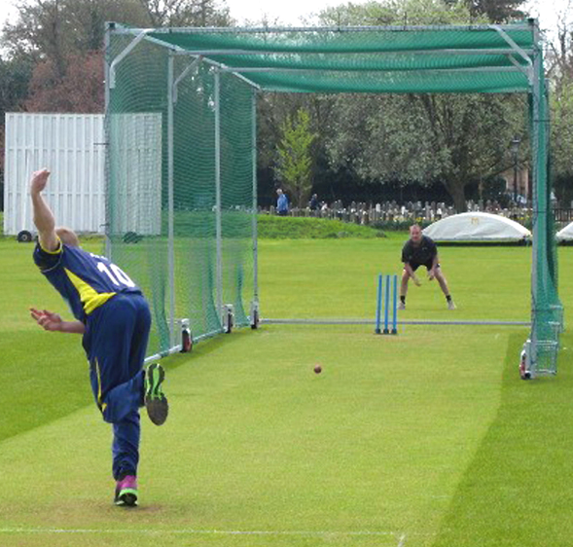 | There has been some confusion about the use of the batting cages which were acquired as part of CricketForce. Obviously we have to balance the need for quality practice with the demands of an already heavy workload on the square. As such, use of the cages is limited to official practice sessions - Tuesday evening (men’s 1s/2s), Thursday evening (club) and Friday evening (juniors) - and strictly under the direction of groundsman, Roger Price. They are only to be used in dry conditions, on the end strips and should be returned to the edge of the pitch after use. Any questions, please get in touch.

Membership

With the season well underway, we will be issuing warnings over the next couple of weeks to those who have yet to pay their subscriptions. If these warnings are unheeded, we will assume you are unavailable. Please make your life and the life of your captains / membership team easier by paying promptly! Remember they are all volunteers and the club has bills to pay…

Social Calendar

24 June | Club social hosted by the 2nd XI
8 July | Club social hosted by the 4th XI
22 July | Club social hosted by the 6th XI
29 July | Club social hosted by the 3rd XI
5 Aug | Streatham CC & Marlborough CC Old Boys Day
12 Aug | Club social hosted by the 5th XI
26 Aug | Club social hosted by the 1st XI
27 Aug | Presidents Day
2 Sep | Club social hosted by the Ladies XI

Finally, best of luck to our all our players at the weekend.

Cheers,
Dan

Proudly supported by:

1st XI
Won by 5 wickets
Old Wimbledonians 175ao (51.3) / SMCC 176-5 (49.4)
1st XI League position – 4th / 10
Report: N/A

2nd XI
Losing Draw
SMCC 260-6 (55) / Old Wimbledonians 239-9 (45)
2nd XI League position – 9th / 10
Report: The 2s travelled to Old Wimbledonians who had a 100% record heading in to week 5. Sharif lost the toss and SMCC were asked to bat first. Johnson got off to a solid start, driving with commitment and punishing anything short and wide. An early wicket at the other end brought Shah to the crease and he quickly joined Johnson in dispatching the bad ball. Both batsmen were enjoying the pace on the ball and took us to drinks having built a solid platform with Johnson having passed the 50 mark. Unfortunately, the curse of drinks reared its ugly head and Johnson was caught after OWCC took the pace off the ball for a well-made 66. The introduction of spin took Shah and Acheson a little time to adjust but they continued to put the bad ball away and rotate the strike. Shah joined Johnson in passing the 50 mark and soon began to tire as OWCC resorted to putting 7 fielders out on the boundary. Acheson too passed his 50 and was batting superbly and running the leggy Shah ragged. With 191 on the board at the 45 over mark, the message was for Shah to “hit out or get out”. He tried both, to no avail before resorting to slowly trotting a single so OWCC could run him out. They obliged and Shah’s impressive innings came to an end on 58. Some powerful hitting and good running ensued before Acheson fell for a brilliant 86. SMCC finished on 260-6 after 55 overs.

The second half of the day saw SMCC get off to a good start with Haughton snaring an early wicket with a ferocious short ball. Sharif equalised shortly after at the other end and OWCC’s opening pair had departed. Keenan replaced Haughton and grabbed a wicket of his own to leave OWCC at 74-3. Unfortunately OWCC began to pull away at this point and a 100 run partnership enabled them to gain control of the game before Fuller made the vital breakthrough. The OW number 3 continued to bat stubbornly and tested SMCC’s fielders with some dodgy looking singles. Eventually, Naik ran him out on 94 but the game was still in OW’s hands as they were 227-5 with 10 overs remaining. Kidd then took 2 quick wickets to leave OWCC 7 down with 230 on the board. Sharif then came back to grab another victim and OW were reeling at 239-8. All of a sudden the game was in the balance with all 3 results a distinct possibility. Kidd then bowled the number 10 and SMCC smelt victory from the jaws of defeat. Unfortunately, OW’s number 9 rode his luck and shut up shop to leave SMCC with a frustrating, yet brilliant 10 points.

In last week’s report, I said we are “capable of putting up a good fight in this division but we must start showing it sooner rather than later”. We certainly did that on Saturday which lead to the opposition skipper remarking that we should not be where we are in the league as we were OW’s toughest challenge to date. More of the same on Saturday chaps. (A Sharif)

3rd XI
Won by 61 runs
SMCC 210-8 (47) / Old Rutlishians 149ao (38.2)
3rd XI League position – 5th / 10
Report: The 3rd XI travelled to deepest Mitcham to take on unbeaten Old Rutlishians. It looked like a pitch on which it would be foolish to do other than bowl first. Driscoll unfortunately lost the toss and we were sent in. McNeill Adams and Bartolo perished early and we were in a spot of bother on 27 for 2. Little and Lawrence rebuilt the innings in impressive fashion, with both batsmen merciless in punishing anything loose. They progressed to 119 before Lawrence was lured down the pitch and stumped for 57. Two balls later, Chowdhury was back in the hutch as well. He performed better on the sidelines, presenting the rest of the team with an attractive set of deals for bespoke curtains and quizzing them about their favourite words. When Hughes was dismissed a few overs later, trouble again loomed. However, after Little was dismissed for 69, excellent lower order batting from Driscoll and Lee got us up to a strong total of 210 for 8 off 47 overs. Both played some wonderful strokes. A Lee shimmy down the pitch to play an inside out drive through extra cover was undoubtedly the shot of the day. Tea was pretty decent, with Onion Bhajis lining up next to traditional favourites such as egg sandwiches and cake. A lack of any mugs of tea was the only disappointment.

We felt buoyant as we took the field and started extremely positively. Driscoll removed one opener and Lee kept it tight at the other end. After 10, Old Ruts were on 26 for 1. Gladstone then took two, combining with McNeill Adams for a sharp stumping and Little for a good catch at slip. There was an unwelcome intervention from the Old Ruts chairman, who attempted to argue that the match should be increased by ten overs. Credit must go to the opposition captain for shutting this idea down immediately. Singh bowled a dangerous spell without luck and Thomas broke a threatening partnership, helped by a good catch by Hughes, to leave Old Ruts 98 for 4. Lee then returned and extracted some extra bounce to remove their number 6, who gloved through to McNeill Adams. Gladstone dismissed the classy number 5, who had played some glorious shots through mid-wicket. We needed to take the final 5 wickets in 10 overs. The match looked to be in the balance, but Lee bowled like a dream to dispel any doubts about the result. Three batsmen were castled by a succession of unplayable yorkers, one of which was a magnificently disguised slower ball. With 5 overs to go, Lee sealed a 61 run win by trapping their number 8 in front.

This was an impressive, characterful performance from the 3s. The fielding was much improved, with almost every ball accompanied by energetic chasing and backing up. The only blot was Chowdhury’s idiosyncratic attempt to effect a run out from the boundary by looping the ball in underarm. (H McNeill Adams)

4th XI
Won by 66 runs
SMCC 229-9 (40.5) / Walton on Thames 163ao (44)
4th XI League position – Joint 3rd / 10
Report: N/A

5th XI
No fixture – planned league gap week
5th XI League position – 6th / 9

6th XI
No fixture – planned league gap week
6th XI League position – 6th / 9

Ladies 1st XI
No fixture
Ladies 1st XI League position – 1st / 12

