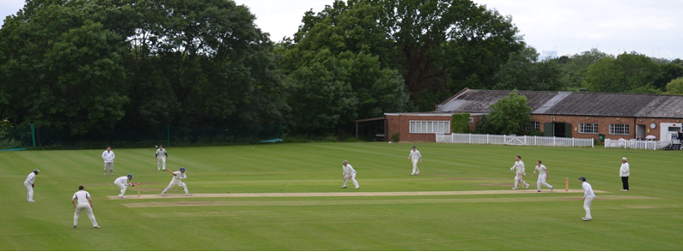
Streatham & Marlborough Cricket Club
Midweek SMS – 16 August 2017

Fixtures | Results | Membership | Club Kit | Fantasy Cricket | Batting Statistics | Bowling Statistics
(Click on these links for further information)

The good news is that the Ladies continue to march their way to the title with another win to remain unbeaten this year. Unfortunately, the men’s 4s were the only side to join them in victory over the weekend.

As far as performances go, let’s start with the women; Jodhan 35* and Quade 35* (now averaging 108!) starred with the bat in a comprehensive victory. On the men’s side, Mayes (10-5-6-4) was the standout bowler whilst Southworth was the only player to record a half century. The Selection Committee voted both men joint Players of the Week.

Now, on to the news and a particular “shout-out” for Presidents Day – all encouraged to attend and support the club!

President’s Day – 27 August – Poster Attached
Come and watch a mini Test Match (2 innings of 20 overs per side) between the Peter Edwards President's Invitation XI and the John Greenwood Chairman’s Invitation XI and meet up with your fellow SMCC players and friends for food, drink and merriment!

The bar will be open from 12 noon. BBQ will be available.

Members and their families, friends and guests welcome.

NatWest OSCA’s – Winner from SMCC!!
At the 10th Annual Outstanding Services to Cricket Awards on Sunday, David Brown was rightly recognised for the sterling work he carried out during the NatWest CricketForce event earlier in the year. It’s only right to stress the time and effort also put in by Raj Patel as well. Without these guys, and the members who put in so many hours graft, we wouldn’t have been able to achieve so much! Thank you all!
Cricket in Dulwich
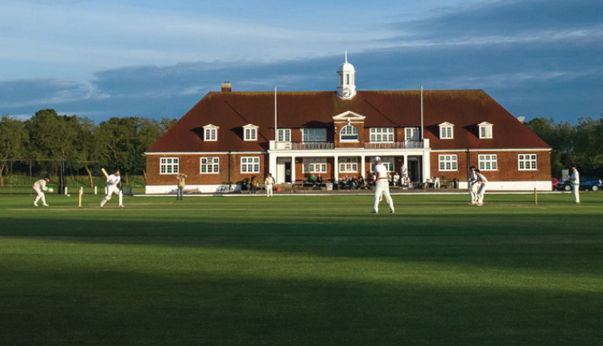 | On the 5th of October, Dulwich College will be hosting a talk on sport within Dulwich. Daniel Norcross (Test Match Sofa) will discuss the future of cricket, especially at school and club level. For more details, please see the attached flyer.

Social Calendar
26 Aug | Club social hosted by the 1st XI
27 Aug | President’s Day
2 Sep  28 Oct | Club social hosted by the Ladies XI  Annual Club Dinner

Best of luck to our all our players at the weekend.

Cheers,
Dan

Proudly supported by:

1st XI
Lost by 109 runs
Addiscombe 266-6 (50) / SMCC 157ao (38.5)
1st XI League position – 3rd / 10
Report: N/A

2nd XI
Lost by 5 wickets
SMCC 141ao (44.4) / Beddington 142-5 (44.4)
2nd XI League position – 9th / 10
Report: Sharif lost the toss and SMCC were asked to bat first on what was a worn wicket that was a little soft on the top due to the week's rain. Runs were not easy to come by as the ball often kept low on a length and there was little value for good shots as the outfield was painfully slow. Despite Shah and Acheson's best efforts at the top of the order, they were unable to occupy the crease for too long. The story continued for most Boro batsmen as wickets fell at a steady rate. Williamson tried to take the attack to the Beddington bowlers but fell trying one lofted drive too many after hitting three much needed boundaries. Mayes looked to squeeze as many runs as possible out of the innings but some poor running under pressure towards the end of the innings meant SMCC closed on 141. Considering the wicket, this was probably just 30-40 runs short of a decent total.
SMCC took to the field knowing early wickets would be key. Unfortunately, this didn't quite happen as Beddington benefited from the flattened track and batted sensibly to get off to a steady start. Sharif quickly turned to spin and Mayes made the breakthrough. He made 3 others throughout his 10 overs and ended with fantastic figures of 10-6-5-4. Allardice and Marquis did their best to try and take a couple of key wickets as well but at 5 down, Beddington's skipper batted sensibly to push ones and twos in order to pass SMCC's total with 5 overs to go. A frustrating loss considering the momentum that was gathered the week before but a great spell of spin bowling from Mayes nonetheless.
The result leaves us a little up against it but we're not out of it yet. It's out of our hands but if we win our last 3 winnable games, we may just survive. After all, it never looked like we'd end up champions with 3 games to go last season... (A Sharif)

3rd XI
Lost by 55 runs
Old Whitgiftians 154ao (41.3) / SMCC 99ao (35)
3rd XI League position – 8th / 10
Report:

4th XI
Won by 4 wickets
SinjunGrammarians 159-9 (42) / SMCC 160-6 (37)
4th XI League position – 4th / 10
Report: An interview with Raj Patel:

Interviewer: Were you ready to rumble?
Raj: To be perfectly honest I was not ready to rumble after seeing the game had been conceded by Sinjuns on Play Cricket on Saturday morning.
Interviewer: But the game went ahead. How did you react to this at such short notice?
Raj: It was very challenging. The first thing I had to do was get Mitch Davies out of bed – it proved a real challenge though he assured me the four-pint rule had not been breached.
Interviewer (nodding): I don’t doubt a difficult task but I was asking more about the game itself? Did you need to do anything to prepare yourself as captain?
Raj: Oh no. The trick here is that I have mastered the art of losing the toss. That way I can think as little as possible before the game; all I have to do is wait to be told what to do by the opposition.
Interviewer: Interesting. So you were asked to bowl - were there any standout performances of moments of interest?
Raj: Well I won’t mention my magnificent spell of 7.5 overs, 1-16 or that I dropped another caught and bowled opportunity. I would have had at least two more if it weren’t for the fact that we weren’t playing LBW.
Interviewer: You weren’t playing LBW?
Raj: Well we weren’t officially informed of this but it was implied by the umpires.
Interviewer: Ok moving on. You were saying that some of the other bowlers had done well..
Raj: Yes in addition to my marvellous spell, the four other bowlers did a fantastic job. Avin Ramani (2-20) bowled nine overs straight to really put them on the backfoot and was ably assisted by Asif Kocker (2-39). Mitch ‘6-10’ Davies took some crucial wickets in the middle to end with 3-23 and Paul Henly (1-53) also performed well despite bowling from the ‘please hit me into the road twice in my first over end’.
Interviewer: It sounds like a real team effort. You must have been pleased to bowl them out for 159 at the half way stage?
Raj: Yes, they only had ten which helped but it really should have been a lot less.
Interviewer: How so?
Raj: We had two reviews go to the third umpire – one for a run out and one for a stumping. On review the batsmen couldn’t be seen in the shot but it turned out to be a dodgy camera rather than the actual position of the batsmen, so they got the benefit of the doubt.
Interviewer: Even so a good first half of the match and you must have been confident going into the chase?
Raj: I’m not sure you have been following the team’s attempts to chase this year! Luckily we got off to a good start. Alex Urquhart and Ben Southworth put on 78 for the first wicket before Letty Clunes made the breakthrough for Sinjuns - Alex caught at midwicket for 21.
Interviewer: A solid beginning but if I am not mistaken this is where the game got interesting?
Raj: Indeed. Letty made quite the impression on the game. His nine over spell also accounted for Southworth (50), Jim Hughes (18) and Rupesh Amin (16) to leave SMCC 119-4. Having labelled Alex the nightwatchman, he was particularly pleased to remove Ben.
Ben: He made sure I knew how good he was as I trudged off. He even suggested I google him to find out more.
Interviewer: Did you?
Ben: I did and I was amazed to find that Letty is the name of Selina Cadell’s daughter and that Sigourney Weaver, a close friend of Cadell, appeared in Doc Martin with Martin Clunes in 2015. I think maybe they are cousins.
Interviewer: Raj, 40 still needed and two new batsmen at the crease, you must have been strapping on the pads, eager to play a captain’s knock.
Raj: To be honest, it didn’t cross my mind. Avin Ramani and David Cook (24) proved I was right to have faith in the team as they took us to within six runs of victory. I couldn’t put myself in ahead of a man now averaging in the 70’s for the season.
Interviewer: So that leaves you 154-5. But you won by four wickets?
Asif: I didn’t really want to bat anyway. I’d already had a decent bowl and Paul had been bugging me for ages about how much he wanted to bat.
Raj: Asif didn’t trouble the scorers but Avin (21*) saw us home and we left fairly quickly after that.
Interviewer: A great win – you must be looking forward to a return fixture next season?
Raj: No, I’m not.
(Ben Southworth)

5th XI
LESSA Christ Church 118-9 (40) / SMCC 114-8 (40)
5th XI League position – 6th / 9
Report:

6th XI
Match conceded due to insufficient players (over 30 unavailable across the club!)
6th XI League position – 6th / 7
Report:

Ladies 1st XI
SMCC 181-4 (30) / South Nutfield 114-7 (30)
Ladies 1st XI League position – 1st / 12
Report:

Academy XI
Academy XI League position – 7th / 7

