**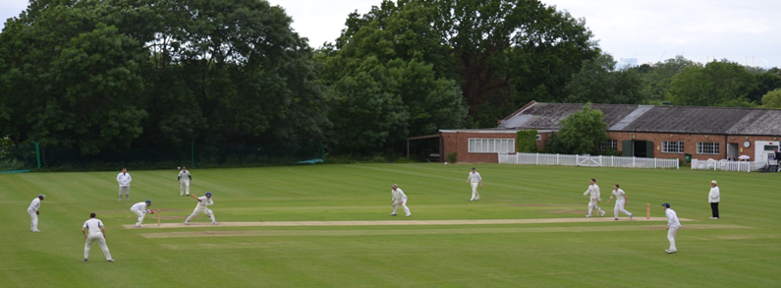**

**Streatham & Marlborough Cricket Club**

**Midweek SMS – 9 August 2017**

|  |  |  |  |  |  |  |
| --- | --- | --- | --- | --- | --- | --- |
| [**Fixtures**](http://stmcc.play-cricket.com/website/web_pages/112572) | [**Results**](http://stmcc.play-cricket.com/website/web_pages/112573) | [**Membership**](http://www.streathammarlboroughcc.co.uk/index.php/membership/) | [**Club Kit**](http://www.allroundercricket.com/teamwear/cricket-teamwear/s/streatham-and-marlborough-cc) | [**Fantasy Cricket**](http://stmcc.fantasyclubcricket.co.uk/) | [**Batting Statistics**](http://stmcc.play-cricket.com/website/web_pages/112576) | [**Bowling Statistics**](http://stmcc.play-cricket.com/website/web_pages/112577) |
| (Click on these links for further information) | | | | | | |

As we head into the part of the season known as squeaky bum time… I thought we should recap on where our sides are positioned. Victory for the 1s has put them to the top of the table joining the (unbeaten) Ladies 1s who have been there for the majority of the season. The 2s are looking to pull off the great escape whilst the 3s will be nervously looking over their shoulder and need a couple of result. The 4s and 6s reside in mid-table as the 5s look to mount a late promotion charge. Finally, the young academy side are gaining good experience in a tough league where results are hard to come by.

Last weekends completed games have given me the chance to highlight some performances again. Ellis (57\*), Little (52\*) and Hughes (59) made useful contributions with the bat; Davis (4-38) and Patel (4-12) performed with the ball. Well done guys!

And… just to echo the Chairman’s recent post on Facebook regarding players dropping out. **Don’t do it!!** The selection committee spend a considerable amount of time organising and late withdrawals add a considerable workload to those who already volunteer their time for your benefit. It’s not fair to them or your fellow members so please only do it in exceptional circumstances.

Rant over… on to the news…

**5th XI Social – Sausage Sizzle**

|  |  |
| --- | --- |
| cid:image012.jpg@01D31116.F3B64DC0 | This Saturday, Laurie and the 5th XI will be putting on a sausage sizzle to feed the masses after a raft of victories… Please support them and the club! |

**President’s Day – 27 August – Poster Attached**

|  |  |
| --- | --- |
| cid:image012.jpg@01D071F6.C72441C0 | Come and watch a mini Test Match (2 innings of 20 overs per side) between the Peter Edwards President's Invitation XI and the John Greenwood Chairman’s Invitation XI and meet up with your fellow SMCC players and friends for food, drink and merriment!  The bar will be open from 12 noon. BBQ will be available.  Members and their families, friends and guests welcome. |

**Social Calendar**

|  |  |  |  |  |  |  |  |  |  |
| --- | --- | --- | --- | --- | --- | --- | --- | --- | --- |
| 20160909_192229.jpg | |  |  | | --- | --- | | 12 Aug | Club social hosted by the 5th XI | | 26 Aug | Club social hosted by the 1st XI | | 27 Aug | President’s Day | | 2 Sep  28 Oct | Club social hosted by the Ladies XI  Annual Club Dinner | |

Best of luck to our all our players at the weekend.

Cheers,

Dan

[](http://www.streathammarlboroughcc.co.uk/)

Proudly supported by:  
  
[](http://bilmesllp.com/)

[cid:image021.png@01D2B90A.9B143510](http://www.mirash.co.uk/)[](https://www.premiercurtains.com/home)[](http://www.brownbuilding.co.uk/)

[cid:image025.png@01D2B90A.9B143510](https://www.facebook.com/groups/SMCricketClub/)[cid:image026.png@01D2B90A.9B143510](https://twitter.com/smcricketclub?lang=en)

**1st XI**

Won by 7 wickets (revised total)

Old Wimbledonians 137ao (46) / SMCC 131-3 (27.3)

1st XI League position – 1st / 10

Report: N/A

**2nd XI**

Won by 9 runs

SMCC 203-8 (50) / Old Wimbledonians 194ao (49.1)

2nd XI League position – 9th / 10

Report: The 2s faced title chasers Old Wimbledonians on Saturday in a must win fixture. Things didn't start well as Sharif lost the toss and SMCC were asked to bat with spells of rain forecast for the afternoon. Runs were hard to come by at the start as the Boro reach 50-1 at the first rain break after 20 overs. With a wet ball, the runs flowed a little more freely as Little batted in partnership with most of the middle order to gradually push the score towards a respectable total. A fruitful last 15 overs enabled SMCC to post a respectable 203 with Little finishing 52 not out. A great innings full of determination to stay at the crease, combined with run scoring shots towards the end meant we had a decent total to defend.

OWCC got off to a flying start and raced past the 50 mark for no loss before Mayes caught well at cover from a Sharif delivery to send the dangerous opening bat back to the hut. Keenan came on to grab two wickets in two balls with Muir taking a great low catch at cover. This left OWCC at 67-3 with the Boro sensing this was going to be a fragile period for the visitors. 2 mini recoveries took them 127-5 with 15 overs left. The game was firmly in the balance as Muir and Ramani bowled tight spells to keep SMCC in the game. At 160-6 with 8 overs left, it looked as though the tie was slipping from SMCC's grasp. Wickets were now needed. Mayes made a vital breakthrough which was followed by a run out by Williamson to leave OWCC at 187-7 with 3 overs to go. Some extras were gifted and another wicket was taken to leave Old Wimbledonians needing 9 from the last over with 1 wicket in hand. Unfortunately for the visitors, OWCC's number 10 snicked a Sharif delivery in to the grateful gloves of Knott who did his best to shell it before gaining enough control to throw the ball straight up in the air in jubilation at what was a fantastic win.

A great performance from the boys leaves us right in the mix with 4 games to go. If we show the same fight and determination as we have in the last 2 weeks, I've no doubt we'll pull off the great escape. Work still to be done though! (A Sharif)

**3rd XI**

Lost by 150 runs

Old Rutlishians 240-8 (45) / SMCC 90ao (24.1)

3rd XI League position – 8th / 10

Report:

**4th XI**

Won by 104 runs

SMCC 206-8 (45) / Walton on Thames 102ao (34.2)

4th XI League position – 5th / 10

Report:

**5th XI**

Gap week

5th XI League position – 4th / 9

Report:

**6th XI**

Gap week

6th XI League position – 5th / 8

Report:

**Ladies 1st XI**

Gap week

Ladies 1st XI League position – 1st / 12

Report:

**Academy XI**

Lost by 9 wickets

SMCC 121ao (26.5) / Oxted & Limpsfield 123-1 (18.3)

Academy XI League position – 7th / 7

Report: N/A